2016

The French Competitiveness Clusters Association

MEMBERS DIRECTORY D’ACTIVITÉS

SUMMARY

THE FRENCH COMPETITIVENESS CLUSTERS 3

What is a « French pôle de compétitivité » ? 3

What objectives do "pôles de compétitivité" have ? 3

What public support is available for “French pôles de compétitivité” ? 4

What is the French “pôles de compétitivé”' profile? 5

Map of Competitiveness clusters (April 2016) 6

THE FRENCH COMPETITIVENESS CLUSTERS ASSOCIATION 7

AFPC's Missions 7

AFPC MEMBERS DIRECTORY 9

AEROSPACE VALLEY 11

ADVANCITY 12

THE FRENCH COMPETITIVENESS CLUSTERS

What is a « French pôle de compétitivité » ?
A French “pôle de compétitivité” is a partnership, based around a specific theme and a specific region. A “pôle de compétitivité” (competitiveness cluster ou cluster) brings together large and small firms, research bodies and educational establishments, all working together in a specific region to develop synergies and cooperative efforts around a shared theme.

Clusters think big
The goal of clusters is to build on synergies and collaborative innovation projects in order to give partner firms the chance to become first in their markets, both in France and abroad.

What objectives do "pôles de compétitivité" have ?

Clusters serving business and job growth
Clusters help to make the French economy more competitive. They develop growth and jobs in key markets by:
- stepping up companies' innovation efforts and supporting mainly industrial activities with a large technological component;
- improving the attractiveness of France through greater international visibility.

Boosting the economic benefits of the clusters' dynamism
The core activity of the clusters is to develop collaborative innovation projects, while integrating the potential economic benefits as early as possible. Clusters meet two priorities:
- reinforcing the economic benefits of R&D projects. The clusters become factories for tomorrow's products. They transform collaborative R&D efforts into innovative products, processes and services released onto the market;
- supporting the growth of SMEs and mid-tier companies (ETIs) by offering collective and individual services in the following areas: access to financing, international development, the forecasting of companies' needs in terms of skills and individual assistance with the development of SMEs, including advice and tutoring.

What public support is available for “French pôles de compétitivité” ?
France is committed to creating a conducive environment for both firms and innovation. It helps companies to derive the economic benefits of innovation.

For instance, at national and regional level, France and its regions back the development of clusters:
- Through calls for projects launched by the FUI and under the Invest for the Future Programme resulting in financial assistance for the best nation-wide collaborative public-private R&D projects;
- By granting loans to member SMEs or ETIs that wish to embark on the industrialisation and marketing of the results of a collaborative R&D project. This loan for the industrialisation of cluster projects (PIPC) is financed by the Invest for the Future Programme;
- By helping clusters and their member firms find the best international partners and set up technological partnerships with them focused on value creation;
- By supporting the clusters' governance structures, alongside firms. This support enables the introduction of theme-based collective initiatives launched by the clusters, in a wide variety of fields and involving the cluster's firms, particularly including SMEs, so as to promote innovation and improve their competitiveness;
- By involving various partners in this policy, including the French National Research Agency (Agence Nationale de la Recherche or ANR), Public investment bank (Bpifrance), the Environment Agency and the energy conservation (ADEME), the Deposits and Consignments Fund (Caisse des Dépôts et Consignations ou CDC) and Business France.

Public-sector support for R&D projects
Between 2005 and 2013, 1,313 collaborative R&D projects received public financing of €2.37 billion, including more than €1.45 billion granted by the French State through the dedicated fund (FUI). These projects, amounting to nearly €6 billion in R&D expenditure, involved close to 15,000 researchers.

What is the French “pôles de compétitivé”' profile?
The clusters cover most sectors of activity, from emerging high-tech fields (nanotechnologies, biotechnologies, ecotechnologies, and so on) to more mature sectors (automotive, aerospace, etc.).
- In 2011, each cluster had an average of 187 members (108 SMEs, 16 ETIs, 13 major groups and 31 research and training organisations).
- Their average budget was around €1.3m (with FTE employees).
- Their leadership teams were small (8 FTE employees) and stable (more than 3 years in the job).

SME involvement in clusters
- 86% of SMEs: In 2011, 86% of the clusters' 7,500 member firms were SMEs, 12% were ETIs and 2% were major companies.
- 63% of subsidies: In 2013, SMEs received 67% of the financial support granted to companies by the State fund dedicated to collaborative R&D projects (Fonds unique interministériel, FUI).

Map of Competitiveness clusters (April 2016)

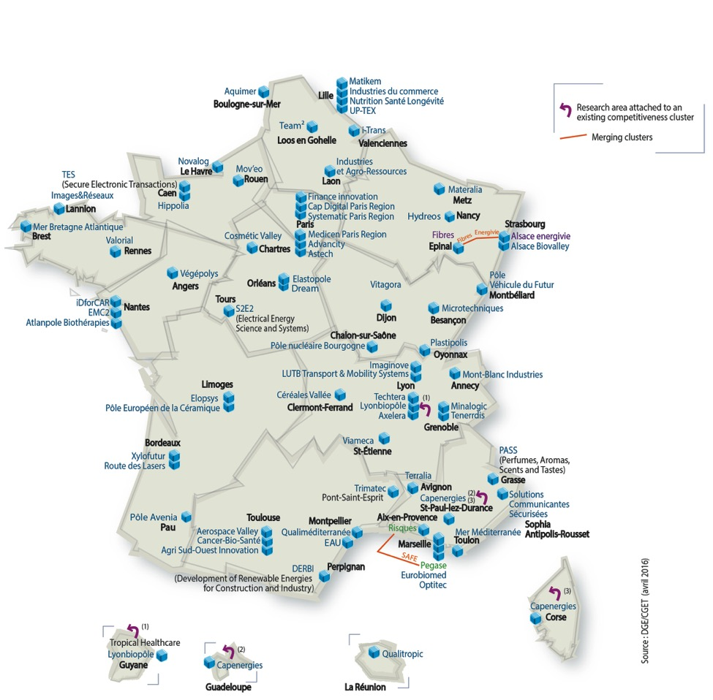
For more information about Competitiveness clusters : www.competitivite.gouv.fr/en

THE FRENCH COMPETITIVENESS CLUSTERS ASSOCIATION

The French Competitiveness and Business Clusters Association (AFPC) unites 55 out of 69 French Competitiveness Clusters, representing 9 900 SMEs, 3 000 universities and laboratories (15 000 researchers), and more than 1 000 large and medium-sized companies (100% of French CAC40). AFPC has the following missions managed by 3 committees aiming to enhance the role of clusters in the innovation dynamics with the government and the regions, to be the voice of the clusters and their members for national and European authorities and to support research funding for SMEs.

AFPC's Missions
Established on the 16th December of 2013 with the support of the Caisse des Dépôts et Consignations and the DGE (Minister for the Economy, Industry and Digital Affairs), AFPC aims to achieve three missions:

Mission 1: Enhance the role of clusters in the innovation dynamics with the government and the regions
AFPC will promote the coordination of actions of the various clusters and the development of inter-clusters collaborations. The aim is to underline the many achievements in the various territorial ecosystems, in terms of product innovation, businesses and job creation. The purpose carried on by AFPC is to increase public funding granted to them and to ensure the involvement of clusters in different plans, channels and programs initiated, including the Ministry for Industrial Renewal of France: accelerate deployment of the Industry of the Future and the nine industrial solutions in France and internationally.

Mission 2: Be the voice of the Clusters and their Members for National and European Authorities
At a European level, AFPC interacts with the European Commission in the framework of "smart Specialization strategies" in coordination with regions to expand collaborations with clusters and EU organizations.
AFPC also seeks to involve a greater number of companies in community programs such as Horizon 2020 or COSME. While Germany and the Scandinavian countries have structured and coordinated their innovative policy ecosystems, France needs to strengthen it's European presence.

Mission 3: Support and Promote the Clusters' SMEs Members

AFPC focuses on facilitating access to private funding for innovative business. Financing is key to ensure the growth of SMBs, establish their competitiveness and enable them to become intermediate-sized businesses with a French influence in international markets.
As such, AFPC follows up on the "EIP" Label established in June 2010 and which is subject to a chart signed by 55 clusters. SMBs labelled EIP by their clusters have close support of professionals throughout fundraising.
Moreover, AFPC supports SMBs on several of their major growth drivers: Business, Access to public procurement contracts, Access to purchases of the large industrial groups,...

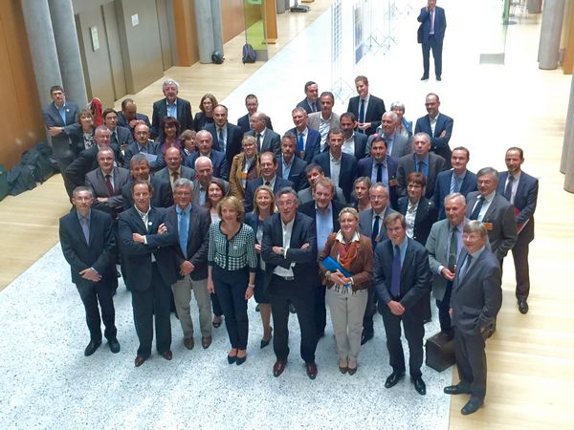

AFPC MEMBERS DIRECTORY

Advancity
Aerospace Valley
Agri Sud Ouest Innovation
Alsace Biovalley
Aquimer
Astech Paris-Region
Atlanpole Biotherapies
Axelera
Cap Digital
Céréales Vallée
Elastopôle
Emc2
Eurobiomed
Fibres Energivie
Finance Innovation
I-Trans
ID4CAR
Images & Réseaux
Imaginove
Industries et Agro-Ressources
LUTB
Lyon Biopôle
Materalia
Matikem
Medicen Paris Region
Mer Bretagne Atlantique
Mer Méditerranée
Microtechniques
Minalogic
Mont-Blanc Industries
Mov'eo
Nov@log
Nutrition Santé Longévité
Optitec
PICOM (Industries du Commerce)
Plastipolis
Pôle Européen de la Céramique
Pôle Nucléaire Bourgogne
Route des Lasers
S2E2
Safe
SCS
Systematic Paris Region
Team2
Techtera
Tenerrdis
Up-Tex
Valorial
Vegepolys
Véhicule du Futur
Viameca
Vitagora

 | AEROSPACE VALLEY  Region : Nouvelle Aquitaine / Occitanie  European Manager : Fabienne DAVERAN  Tel: +33 (0)5 61 14 80 37 - +33 (0)6 11 35 87 36  Email: daveran@aerospace-valley.com
Industrial Sectors: (4 max)
Aerospace Vehicles and Defense
Information Technology and Analytical Instruments
Technology fields: (cf champs Carto excel)
Augmented reality - Big data - Smart Cities - Smart Systems - Factory of the Future - Intelligent Transport System - Urban Mobility - Green Vehicle - Safety & Security - E Health - Equipment for Healthcare - Aerospace - Photonique
Mission/Objectives: (10 Lignes max)
Created in 2005, with today 854 members from both industry and academia, Aerospace Valley is the most significant innovation “pôle de compétitivité” in France in the field of aeronautics, space and embedded systems. With offices in Toulouse (HQ) and Bordeaux, the cluster covers the two geographically adjacent regions of South-West France, Midi-Pyrénées and Aquitaine. With 124,000 industrial employees, Aerospace Valley represents around 1/3 of the French aerospace workforce. Similarly, 8,500 researchers and scientists are active within the Aerospace Valley territory, thus representing 45% of French national R&D potential in the aerospace sector. As of October 2015, Aerospace Valley has obtained funding for 450 R&D projects representing an accumulated value of 1.1 billion Euro covering most scientific and technical fields related to the sectors of aerospace.
Main countries addressed by the cluster organisation through trans-national activities: Germany, Greece, Italy, Poland, Spain
Participation in Funded Support European Programmes / Ongoing Name Projects : Jupiter (H2020), Abroad (COSME), Space2ID(COSME), RueAero (COSME), FabSpace 2.0 (H2020), Cosmos 2020 (H2020), ESA-GDC (ESA), VIP4SME (H2020), Mathisis ((H2020), Perseus (FP7), Capadoccia (FP7)
Composition of the cluster: Total number of members: 854 ; Number of SME members: 500
Cluster Excellence Label: GOLD Label
Website: www.aerospace-valley.com/en
ECCP Profile: http://www.clustercollaboration.eu/cluster-organisations/aerospace-valley
Twitter Account: xxx
LinkedIn Account: xxx
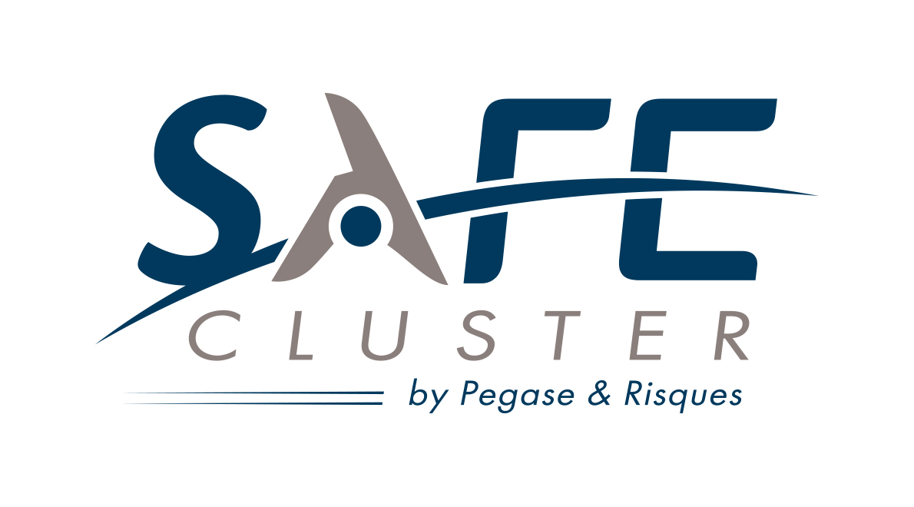 | SAFE CLUSTER  Region : Provence-Alpes-Côte d’Azur  European Manager : Géraud PARJADIS  Tel: +33 (0)4 42 12 30 50 - +33 (0)6 10 29 50 71  Email: geraud.parjadis@safecluster.com
Industrial Sectors: (4 max)
Aerospace Vehicles and Defense
Environmental Services
Digital Industries
Environmental Industries
Technology fields: (se reporter aux champs de la Carto excel)
xxx - xxx - xxx

Mission/Objectives: (10 Lignes max)
Born in December 2015, SAFE Cluster (Security and Aerospace actors for the Future of Earth) is the first French competitiveness hubs focusing on global security.
SAFE Cluster is a French Competitiveness Cluster, which provide support for growth by innovation. Its main expertise concerns the use of aeronautic and space technologies for security and defence applications. It represents 450 members, from the three pillars, industry, academia, and practitioners. SAFE is member of the European Alliance for Security Cluster and the European Aerospace Cluster Partnership.
It aims to become the leading specialised European network in innovative security solutions. To this end, SAFE is supported by the networks, expertise and equipment of its two founding hubs.

Main countries addressed by the cluster organisation through trans-national activities: xxx, xxx
Participation in Funded Support European Programmes / Ongoing Name Projects
- DRIVER : Driving Innovation in Crisis Management for European Resilience (FP7)
- BEAWARE : Bridging East West for Aerospace Research (FP7)
- RAWFIE : Road-, Air- and Water- based Future Internet Experimentation (H2020)
- RUE AERO : Reaching Up to Excellence in Aerospace Cluster Management (COSME)
Composition of the cluster: Total number of members: 450 ; Number of SME members: xxx
Cluster Excellence Label: BRONZE Label
Website: www.safecluster.com
ECCP Profile: http://www.clustercollaboration.eu/cluster-organisations/safe-cluster
Twitter Account: @Safe_Cluster
LinkedIn Account: safe-cluster

