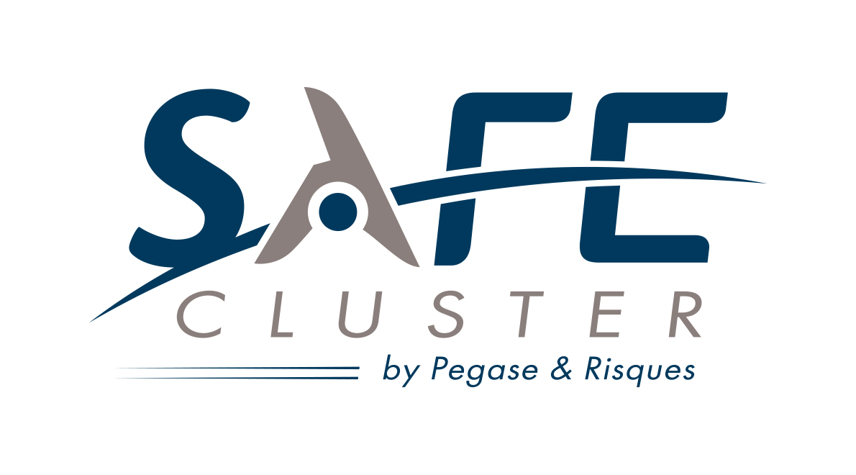 | SAFE Cluster  Region : Provence-Alpes-Côte d’Azur  European Manager : Juliette MALLEZ  Tel: +33 (0)4 42 12 30 50 - +33 (0)7 77 68 64 72  Email: juliette.mallez@safecluster.com
Industrial Sectors:
Security and Defense Industries / Market, UAV system, Helicopter, Satellite & Airship
Technology fields:
Augmented Reality - Big data - Smart Cities - Smart Systems - Factory of the Future - Intelligent Transport System - Green Vehicle - Safety & Security - Aerospace - Photonique - Marine Environment
Mission/Objectives:
Born in December 2015, SAFE Cluster (Security & Aerospace actors for the Future of Earth) is the first French competitiveness hubs focusing on global security.
SAFE Cluster provides support for growth by innovation. Its main expertise concerns the use of aeronautic & space technologies for security & defence applications. It represents 450 members, from the three pillars, industry, academia, & practitioners. SAFE is member of the European Alliance for Security Cluster & the European Aerospace Cluster Partnership. It aims to become the leading specialised European network in innovative security solutions. To this end, SAFE is supported by the networks, expertise & equipment of its two founding hubs.
Main countries addressed by the cluster organisation through trans-national activities: Germany, Italy, Romania, UK
Participation in Funded Support European Programmes / Ongoing Name Projects:
BEAWARE - Bridging East West for Aerospace Research (FP7), RAWFIE - Road-, Air- and Water- based Future Internet Experimentation (H2020); RUE AERO - Reaching Up to Excellence in Aerospace Cluster Management (COSME); DRIVER - Driving Innovation in Crisis Management for European Resilience (FP7)
Composition of the cluster: Total number of members: 450 ; SME members: 270
Cluster Excellence Label: BRONZE Label
Website: www.safecluster.com
ECCP Profile: http://www.clustercollaboration.eu/cluster-organisations/safe-cluster
Twitter Account: @Safe_Cluster
LinkedIn Account: safe-cluster

